31.32: a) 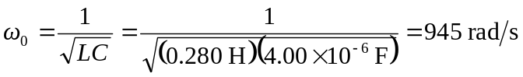.
b) I = 1.20 A at resonance, so: 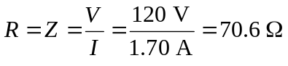
c) At resonance:
